Section 1: System Design & Problem Solving

1. **Web & Mobile Architecture Design**

You are tasked with designing a multi-platform system where a mobile app and a web dashboard communicate with a shared backend. How would you structure the architecture to ensure:

■ Scalability (handling a 10x traffic increase)

■ Security (preventing unauthorized access & data breaches)

■ Maintainability (allowing multiple developers to collaborate efficiently)

Answer :

**Multi-Platform System Design (Web + Mobile with Shared Backend)**

1. Architecture Overview

- [Client Layer]

Mobile App (Ionic/iOS/Android)

Web Dashboard

- [API Layer]

API Gateway

Load Balancer

- [Service Layer]

Auth Service (Laravel)

Business Logic Services

Async Workers

- [Data Layer]

Primary DB (PostgreSQL)

Read Replicas

2. Scalability Design

2.1 Horizontal Scaling

* Stateless API Servers :
  + Containerize Laravel with Docker
  + Use Kubernetes for orchestration
  + Automatically scale based on CPU and RAM metrics
* Database Scaling :

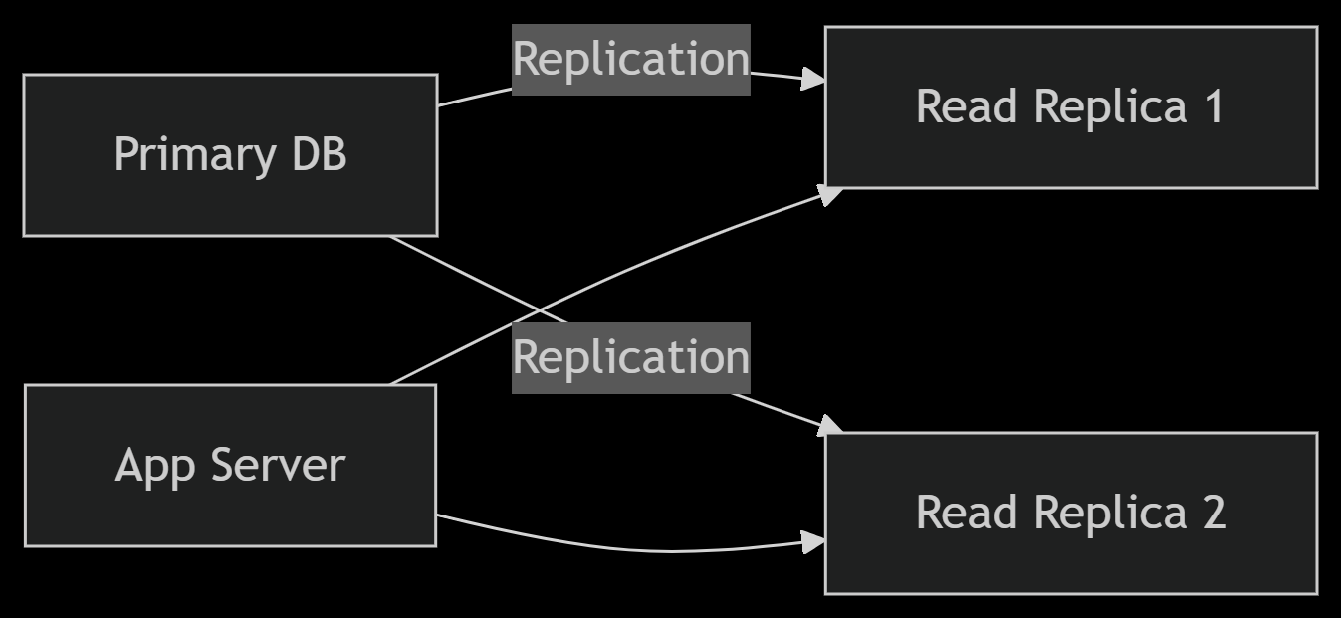

Why Replicas Solve Scaling Issues

1. Handling Read Traffic (The 80/20 Rule)

2. Performance Boost

3. High Availability

2.2 Performance Optimization

* Caching Strategy :
  + Redis for :
    - Session storage
    - API response cache (60s TTL)
    - Frequent queries
* CDN Setup :
  + Cloudflare for static assets
  + Edge caching for media files

3. Security Implementation

3.1 Authentication Flow

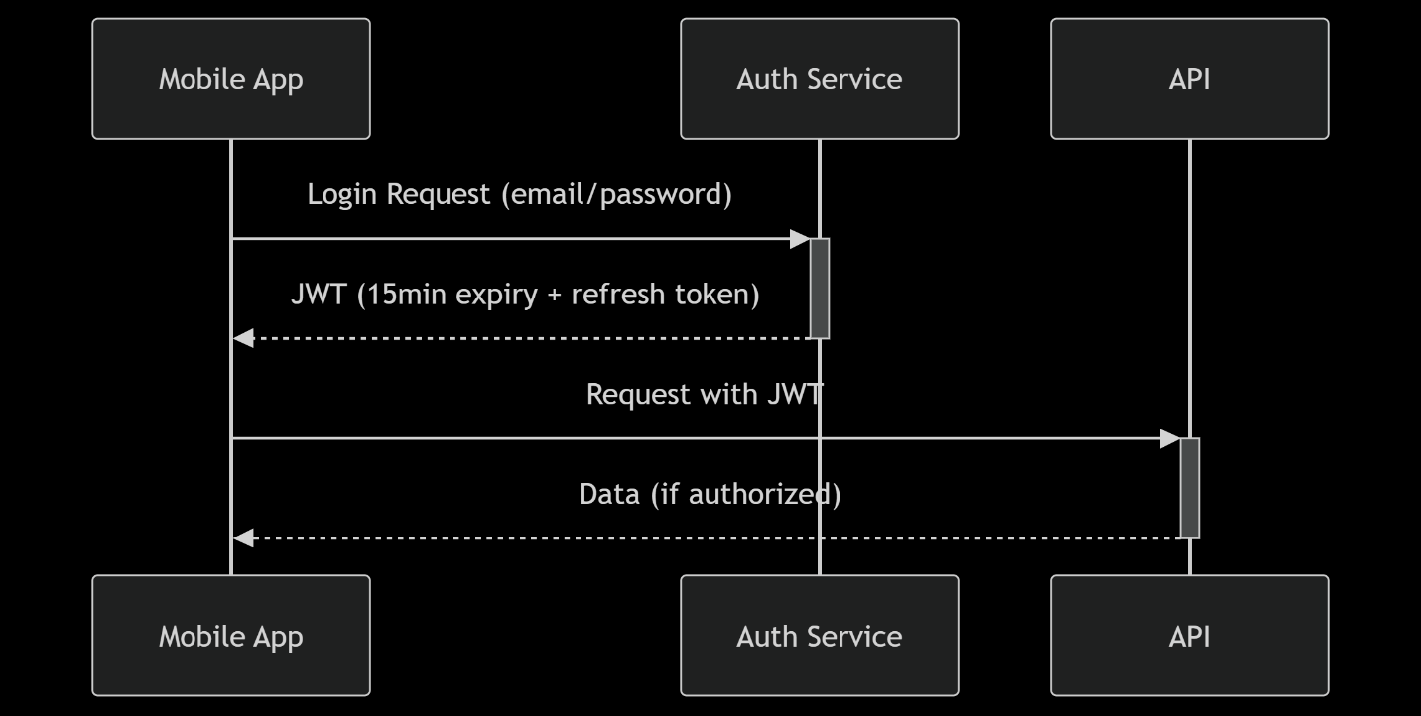

3.2 Key Security Measures

* Data Protection :
  + TLS 1.3 everywhere
  + PII encryption at application level
  + Regular penetration testing
* API Security :
  + Rate limiting (100 requests/min per IP)
  + Request signing for critical endpoints
  + HSTS headers

4. Maintainability Approach

Create Development Workflow

1. Feature branches (Git Flow)
2. PR reviews required
3. Automated testing :
   * Unit tests (PHPUnit/Jest)
4. CI/CD pipeline :



2. **API Design & Optimization**

Design a REST API for securely processing NFC-based transactions. Your

design must address:

■ Authentication using JWT tokens.

■ Data validation to prevent injection attacks.

■ Optimized querying for large transaction data sets.

Answer :

Implemented in project

1. **JWT Works?** ✅
   * Blocks unauthorized access.
2. **Validation Secure?** ✅
   * Blocks SQL/XSS, enforces correct types.
3. **Queries Optimized?** ✅
   * Uses paginate(), indexes, and avoids SELECT *.

3. **Performance Optimization Challenge**

You notice that an application’s response time slows down significantly

when handling large data queries. What steps would you take to:

■ Identify the root cause?

■ Optimize database queries?

■ Reduce load on the server while maintaining fast response times?

Answer :

**1. Identify the Root Cause**

- Laravel Telescope : Inspect slow queries in the "Queries" tab.

- Query Logging

**2. Optimize Database Queries**

- Eager Loading (Laravel Specific)

- Avoid “SELECT *”, select only needed column

- Avoid Subqery, prefers JOIN or EXISTS

- Cursor for Memory Efficiency

**2. Reduce Server Load**

- Use Database Replica

- Queue Heavy Operations

4. **The system needs to process high-volume NFC transactions in real time. How would you:**

○ Optimize the Laravel backend for performance?

○ Minimize API response times in the mobile app?

Answer :

1. **Backend (Laravel)**

* Use queues (Redis) for async processing
* Database: Read replicas + time-series partitioning
* Cache NFC tags/balances in Redis
* JWT with short expiry + refresh tokens

2. **System Design**

* Eventual consistency for transaction status
* Rate limiting + circuit breakers
* Distributed tracing for latency monitoring
* Idempotency keys for duplicate requests
* Offline-first with local transaction queue (Mobile Implementation)
* Predictive pre-fetching of user data (Mobile Implementation)

5. **DevOps & CI/CD Strategy**

Your team is pushing updates frequently. How would you set up a secure,

automated deployment pipeline (CI/CD) that ensures:

■ Zero downtime

■ No breaking changes in production

■ Easy rollback in case of issues

Answer :

**Pipeline Architecture**

Git Flow + Trunk-Based Development:

* main branch = production (protected)
* Feature flags for new functionality
* Automated versioning and tagging

**Zero Downtime**

Setup Deployment Script (using Laravel Forge) :

* php artisan down --render="maintenance"
* git pull origin main
* composer install --no-dev --optimize-autoloader
* php artisan migrate --force
* npm run production
* php artisan up
* php artisan opcache:clear

Or using Kubernetes

strategy:

type: RollingUpdate

rollingUpdate:

maxSurge: 25%

maxUnavailable: 0 # Ensures 100% uptime

**Breaking Change Prevention**

* API Contract Tests: Validate OpenAPI/Swagger specs in CI
* Database Check: php artisan migrate:status --env=testing in pre-deploy
* Laravel Pulse: Real-time monitoring post-deploy

**Instant Rollback Plan**

* Keep previous release folder
* Use Laravel Forge : forge rollback my-app --server=123